2. Lakefinland Cottage HV 102/271 (84m ²) Heinävesi
4 bedrooms, 8 persons (FiFi-Wlan internet possible) email: info@lakefinland.fi
* * * * *

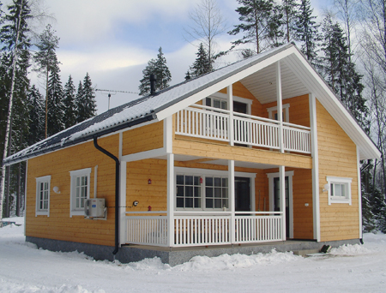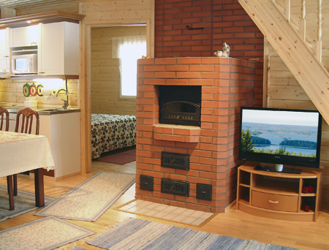

64 km southwest of Joensuu, Lake Kermajärvi/Sappulanlahti 25 m (84 km²), own beach, rowing boat and jetty. Cottage with 2 storeys 2008, downstairs: kitchen, living room, 2 bedrooms with a double bed in each, bathroom, dressing room, sauna (wood burning stove), terrace, upstairs: 2 bedrooms with double bed in each and balcony.

Equipment
Electric light, electric stove, electric fridge-freezer, electric heating, baking oven, hot/cold water, shower, 2 toilets, separate indoor toilet, microwave oven, television, cd-player, vcr, dishwasher, washing machine, drying cupboard for clothes, barbecue

Distances
Helsinki 400 km, railway station 7 km, restaurant 7 km, shop 2,5 km, neighbour 50 m, cross-country skiing track 9 km
Big, well-equipped cottage with 2 storeys in Heinävesi by the Lake Kermajärvi. Good boating, fishing and canoeing possibilities. Shallow sandy shore facing South. Mobile home can be rented for extra price. Good possibilities for grilling with a gas grill. Underfloor heating and baking oven in the cottage. Distance to The Kolovesi National Park 20 km. 7 km to the rapid fishing possibility at Kerma rapid Snowmobile route in near distance, distance to the skiing tracks 9 km and distance to Lekotti ski slope 20 km. A railway at the other side of the bay within sight, some trains daily. Owner brings 20 l drinking water to the cottage. Clients can get more from owners house (tap outdoors) 2,5 km from cottage or they can ask owner to bring more water to the cottage. Reservations start at 16.00 and end at 12.00 (also in weekend bookings). Final cleaning cost will be added to the price.
More pictures next page.. www.lakefinland.fi email: info@lakefinland.fi
